Welcome
Hope this finds you all Covid free and healthy! November is “Adopt a Senior Pet Month”, so we will be discussing this topic this month. We will also cover some Thanksgiving safety tips! If you have any questions or have a topic you would like to hear about please contact our staff at 630-365-9599 or you can contact us via email at 3lburn@sbcglobal.net

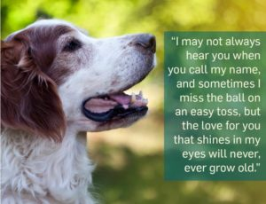

Each year an estimated 860,000 cats and 670,000 dogs are euthanized in our nation’s shelters. Older animals are many times overlooked thinking they may be more difficult. People can be unaware there are so many reasons why these pets can make ideal family members.
It’s so sad to think about all the senior animals that have been parts of a loving home before they suddenly find themselves alone and frightened in a shelter. Often this happens through no fault of their own after their families encounter financial troubles, illnesses, or other problems that have taken place in their lives. By adopting pets like these, you are not only giving them a second home but a second chance at life.
Adopt a Senior Pet Month reminds us that

some older four legged friends need a home too.
While puppies and kittens make us smile, you’d be surprised how an older animal can fit right into your lifestyle as well. Older pets have usually mellowed out and lost some of their youngster energy and don’t need the extra attention a puppy or kitten would require.
There may be some adjustment with an older pet, like humans, they can be set in
their ways. But, usually their history is known and they can be matched with the
right family. So, if you are looking for a companion, don’t forget to check out the older pets.

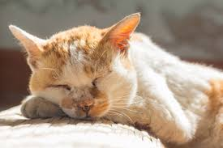

Reasons to adopt an older pet:
*They tend to be less rambunctious than younger animals
*They are often already house broken
*Since they are calmer and less fragile, they can be a great fit for homes with children
*They know you are rescuing them and they are very grateful

Numerous books and articles are available about adopting older pets.



Overindulging in the family feast can be unhealthy for humans, but even worse for pets. Fatty foods are hard for animals to digest. Poultry bones can damage your pet’s digestive track. Holiday sweets can contain ingredients that are poisonous to pets.
*Keep the feast on the table, not under it! Eating turkey fat or turkey skin can cause a life threatening condition in pets know as pancreatitis. Fatty foods are hard for animals to digest, and many foods that are healthy for people
are poisonous to pets – including onions, raisins, grapes and macadamia nuts. If you want your pet to have a special treat for Thanksgiving, make or buy a treat that is made especially for them.
*No pie or other desserts for your pet.
Chocolate is toxic to pets. Many sugar free baked goods and gums, also some candies, contain an artificial sweetener called xylitol, which can also be deadly if consumed by your pet. Xylitol can now be found in some peanut butters, make sure and check the ingredients label.
*Yeast dough (raw) can cause a problem for pets, including painful gas and potentially dangerous bloating.
*Always put the trash away where your pet can’t find it. A turkey carcass sitting on a table, or left in a trash container could also be deadly to your pet. Dispose of turkey carcasses and bones, and anything used to wrap or tie the meat, in a covered and tightly secured trash bag placed in a closed trash container outdoors or someplace where they cannot access it.
*Be careful with decorative plants. Some flowers and plants can be toxic to pets. These include amaryllis, Baby’s Breath, Sweet William, some ferns, hydrangeas and more.
Keep your pets away from all plants and table decorations.
If you believe your pet has been poisoned or has eaten something they shouldn’t have, call your veterinarian or local emergency clinic immediately.

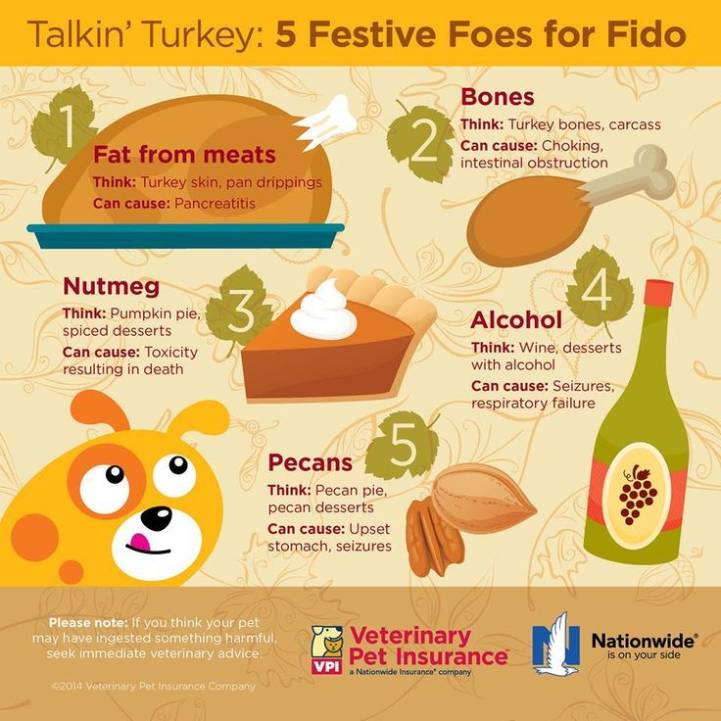

You may also want to call the ASPCA Poison Control Hotline: 888-426-4435. (Some costs may apply) Signs of pet distress can include; sudden change in behavior, depression, pain, vomiting, diarrhea, and excessive drooling.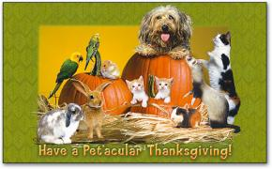

We will be closed Thanksgiving Day, but will reopen on Friday at 8 a.m...
Have a blessed and safe Holiday!

If you have any questions or comments, please email us at 3lburn@sbcglobal.net or call 630-365-9599! If you have a subject you would like covered in our newsletter please let us know!

